C++ Research READ and WRITE to FILES in C++

<http://www.cplusplus.com/doc/tutorial/files/> - read, write to files, read file line by line

<https://www.w3schools.com/cpp/cpp_files.asp> read and write to files, read files line by line using while loop etc.

#include fsteam – used to create, write and write to files.

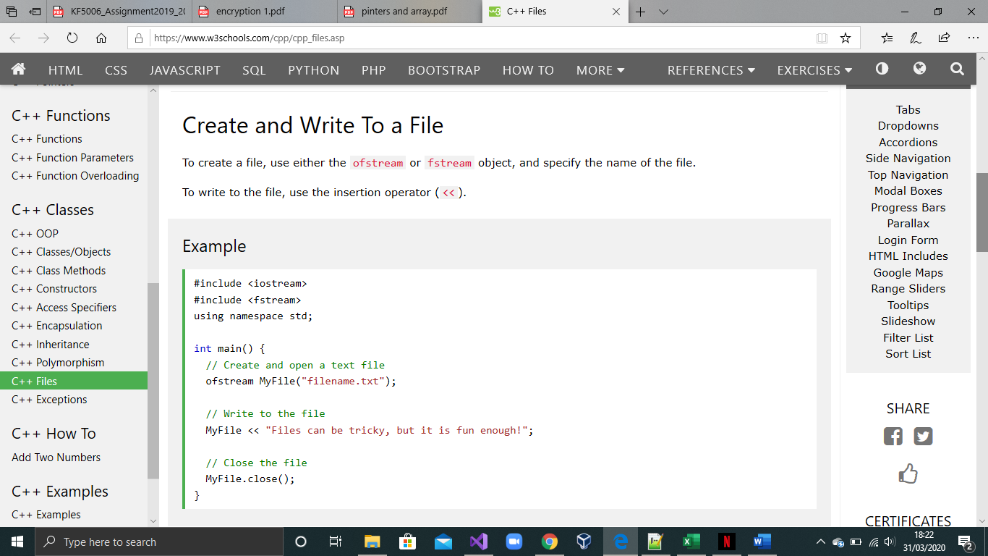Create ans Wite to a file

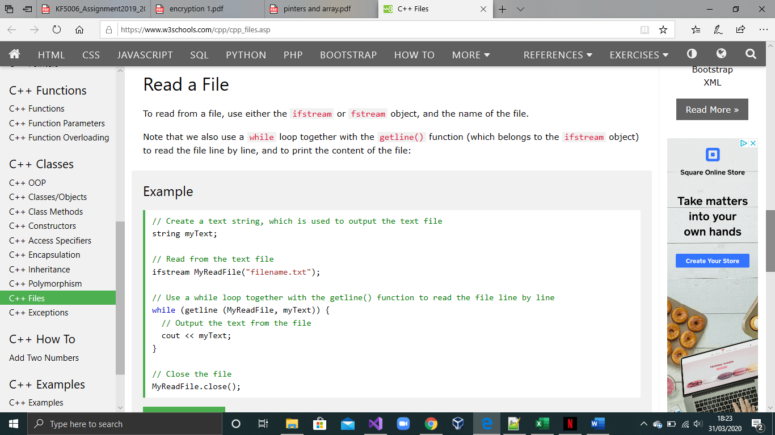

Read a File